Documentation – Assessment 10

Snake App

Project Goal

A functional & fun Snake game for the enjoyment of users.

Project Objectives

A snake game where the snake eats fruit to grow its length. Aim is to survive and get as long as possible. By achieving this I want to gain more confidence in my coding.

Project Scope

1. Snake movements is controlled by pressing arrow keys in the app.
2. Language of app is English
3. Target Audience: Anyone who loves classical mobile games like Snake
4. Game ends when snake hits itself or a wall
5. High score is stored in database
6. A multiplayer option is available (shared phone)

Project Deliverables

* A Instructions page
* A minimum of two Snake maps
  + One without walls (Round World)
  + One with a wall Perimeter (Boxed In)
* A Single Player & Two Player Map

Resources

I will be spending both class time and own time.

I will be using both my personal laptop and mobile to test and build this website.

Internet resources will be used to help me throughout the construction of this app.

I will be personally test this app along with fellow students and family members to help me.

Any defects will be handled through me, internet resources (such as stack overflow), fellow students and the tutor.

ProjectMilestones

1. **10-1-2021**
   * An existing, working **one** player snake game.
2. **25-1-2021**
   * An existing, working **two** player snake game.
3. **19-2-2021**
   * Any additional features to the app.

ProjectSchedule

1. **20-12-2020**
   * Basic Grid setup, with movement keys and user is capable of changing snake direction.
2. **24-12-2020**
   * Snake game ends when hitting an object.
3. **31-12-2020**
   * Snake grows when eating fruit, displays score & snake speed is affected by snake length.
4. **10-1-2021**
   * Adds chilies (speeds snake up temporary) to fruit selection. Single player snake game completed. Fix up menu.
5. **14-1-2021**
   * Two player grid added.
6. **25-1-2021**
   * The two snakes players’ movements and game works.
7. **5-2-2021**
   * Add two maps (Round World & Boxed In).
8. **19-2-2021**
   * Adding Player saves.

ProjectAssumptions

* All users are capable of reading and understanding English
* Users are age suitable for the app

Assessment Progress

**17-12-2020**

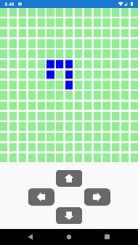Today I chose to build a mobile app on the classic Snake game and started planning around that idea.

I start working on the User’s controls (4 arrows in the app), and I got the grid to display fairly neatly. I sorted out the size of the Snake’s room to roam and started working on giving each arrow a function to control the snake’s movement. There is no current way to die, as you can exceed the grid and also cross over yourself.

Note that the snake has no length currently. It is a single block that leaves a long trail… Like a slug. Here is today’s final screen shot:

**18-12-2020**

I found that this current grid seems too small for the snake to roam in, a family member of mine also shared this view therefore I have changed the 15 x 15 grid to 25 x 25 to allow more space for the snake. Using if statements I have allowed the snake to safely leave the grid and continue on the other side like portals.

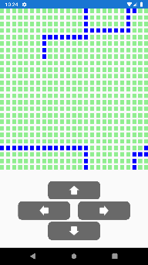I had added a class, which is being used to not only contain the image of each block, but also determine if it is safe for snake to touch or not. If it is **not** the snake movements stop. This will be the end of the game

I have realized that the User should not be capable of turning the snake from left to right, vis versa, up to down or vis versa. I thought about using an if statement in the buttons. Which would work if the user tried to go directly from up to down, but this could be avoided by going from up to pressing left, down quickly before the snake moves. Thus going on top itself, which shouldn’t be allowed. This problem will need to be addressed. Within the function itself. So that if the user tries to go back on itself it’s instead ignored and continues in its current heading. Final Screen Shot:

**22-12-2020**

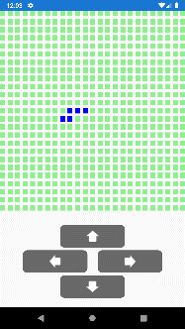I made sure that the snake will start in center of the grid.

Now I included the snake length instead of leaving a slug trail. While testing the updated code in an attempt to move both snake and tail the app would crash with an error: Index was outside the bounds of an array. This would happen because originally I forgot to remove the first char of the tail direction string and even though I thought the snake was turning it was still going up. This was fixed by not only removing the first char of the string but also using if statements to create a portal effect for the tail. Final Screen Shot:

**28-12-2020**

Today I drew 5 fruits and have created a function to add them into the game by random chance and random placement. It also now works to allow the snake to gain more length from eating the fruit.

Originally the snake would gain length but also shed the 1 new block it gained from the fruit. I fixed this by ensuring that the snake direction is updated regardless of whether it eats fruit or not.

I also removed the white gaps between the rows and columns. The snakes speed is also increase as it grows in length and I have added Score into the app.

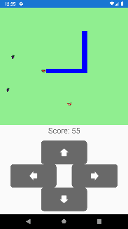I have also managed to prevent the snake doubling back on itself (e.g. Up to Down or Vis Versa) with the use of if statements in the buttons and a public LastSnakeDir variable.

Chili’s now also affects a snake’s speed and increase their speed temporary.

Final Screen Shot:

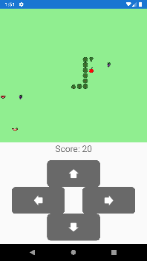**4-1-2021**

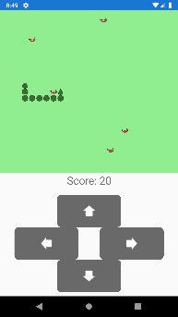I worked on changing the first block to a snake head the rest to body parts and the last block a tail. The trouble was to ensure that it would follow the snake’s trail till the end and not just be a bunch of heads. Using the Tail Dir variable I was able to follow the snake’s path and update the images appropriately. The only problem now is that the head and tail’s rotation does not match it path.

Screen shot of Defect:

With a function to change the image’s rotation based on the snake’s direction on that current block the snake now moves its head and tail appropriately.

Final Screen Shot:

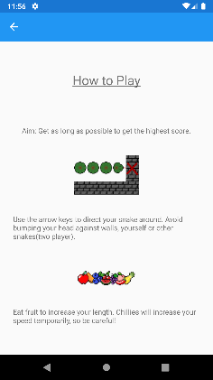**21-1-2021 (In Class)**

I adjusted the snakes speed slightly to allow a faster paced game. I also noticed the some fruit were upside down or sideways due to me rotating the snake’s body parts and leaving the blocks with the rotation even after the snake has left the block. I fixed this so that one the snake leaves the block the rotation goes back to 0.

I created the main page menu, and created the how to play page with instructions of the game. I also added additional fruit as I found I had too many red fruit it looked out of proportion. I now have a total of nine different fruit and I like that the screen now has more variety of colour to it.

Screen shot of How to Play page:

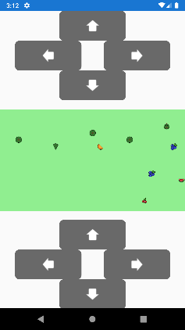I wanted to allow users to choose single player or two player mode for each possible map; to make it simple I planned to have a radio button at the top of the game select page. However I came to realise that without a package radio buttons can’t be made in xamarin c#. After a bit of searching I found that a switch would work perfectly as I only needed two options.

After creating an option for single player or two player with the switch I made a smaller grid for two player that allows space for the second user’s controls. But the problem is for some unknown reason when the snake heads up or down the snake moves seemingly randomly across the grid. When moving horizontally there is a slight issue with the snake’s sense of direction; as if below the first row there is a point where it will dip or rise(depending on direction) to another row. I can’t seem to get the snake to reach the lower rows as well. I’m unsure as to what is causing this issue.

Screen shot of Defect:

I have checked to ensure that the grid size is based completely on the amount of players. The logic for direction is sound and there is no hard code left regarding a 25 x 25 grid in the logic. I’m still confused as to what causes this. I will not add another snake until this issue is resolved.

After going through my code I noted an inconsistency. For the snake finding a new point on the grid the code was:

TheGrid[(tailY * gridY) + tailX]

Whereas for the fruit it was:

TheGrid[((randomY) * gridX) + randomX]

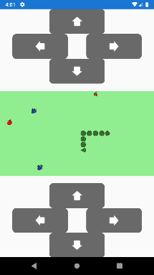I realized looking back at the previous screen shot that the fruit was unaffected as it reached the bottom of the screen. I realized that my logic was flawed. When counting for Y I shouldn’t be worried how many rows total there are; I should be worried how many columns total there are. Because every row had a complete set of columns. This error would never show up in single player because the grid is a square the Y and X values were 25. Because two player had a rectangular grid this flaw in my logic was exposed.

After changing my code to resolve this issue it now works and looks prefect.

Final Screen Shot:

**22-1-2020 (In Class)**

Now that the 2 player grid is ready I need to tidy up my function to allow 2 snakes to move. To do this I removed the section of code that controlled the snakes movement and am attempting to create an independent function to call within a while loop. The goal is for the 2 player function to have two of the move snake function to be running simultaneously within the single wile loop without affecting each other.

I’m having the problem that async does not allow the function to include out’s for some reason. I googled the problem and found Tuples could solve this issue. I got single player working as normal with these changes and will start working towards getting two player to work.

I tried to get it working but it isn’t. The movements of the snake even in single player is confused, and the snake will die for seemingly no reason.

After tidying up my code further; removing unneeded code and simplifying the code to make it tidier and easier to understand the snake is no longer dying on blank tiles. But I can’t move the snake in single player. Interesting enough I seem to be able to move both snakes in two player with their appropriate buttons; although the movements respond better to repetitive tapping of a direction, it will sometimes ignore a single tap. Perhaps something to do with the delay in its function?

I noticed another error with my app. In two player the snakes are constantly waiting for the other snake to move instead of running simultaneously. This will need to be resolved.

After googling I came across Parallel. Invoke which is supposed to allow multiple functions to run together. However when I tried to implement this the snake instantly died on their starting block for some unknown reason. After trying again with each snake being in its isolated while loop the snakes moved smoothly, however, the movements for the snakes are blocked like in single player. For some reason with the snakes moving quickly the current function for the snake movements doesn’t respond to the users’ inputs. It is not the problem with the buttons, it must be a problem with the function if not the snake movement function it will be within the Game On functions.

After looking carefully through the code in the Move Snake function I decided to move the following bit of code that updates the snake’s direction:

//Updating Directions

if (SnakeNum == 1) //Snake 1

{

LastSnakeDir = ThisLastSnakeDir;

SnakeDir = ThisSnakeDir;

}

else //Snake 2

{

LastSnake2Dir = ThisLastSnakeDir;

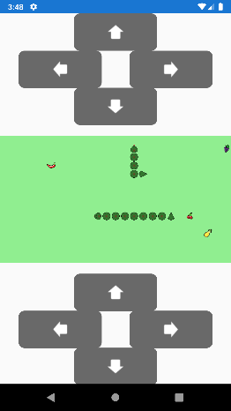 Snake2Dir = ThisSnakeDir;

}

I placed this code *above* the task delay. For both when the snake has consumed chilies and not. This worked! What happened is by putting this before the delay it allowed the user time to change the snakes’ direction before the snake moved and just override anything the user has inputted.

Final Screen Shot:

**28-1-2021 (In Class)**

I have moved the Updating Directions as early in the code as possible without the values being changed as to hopefully allow as much time as possible to update the snakes movement.

In the case of two player I have noticed that if the two snakes were to collide head to head that it should result into a tie and not a win. After creating this function I noticed that it would always run instantly when the page loads. After doing some research I noticed this is because the Parallel.Invoke will run simultaneously but also will not pause the function it is in and will instead continue further in the code. I change this into a task instead to hopefully fix the issue. With a little bit of testing and checking through the new code I got this working. And it allowed for the win lose bit of the function to run at the end of the Game.

I also got it working so that if the snake suddenly turns but still hits an object although the snake would not move into the object as before; but the head will turn in the appropriate direction as if it did try and move into the object.

I noticed that occasionally the screen would change to landscape because of the tilt of the device, which would distort the game and make its controls difficult to use if not impossible I solved this by changing the Activity Flag after reading through this:

<https://stackoverflow.com/questions/22470195/prevent-orientation-change-in-xamarin-android-application>

Now the app only allows for vertical use.

I also made another group of snake skins for the 2nd player in two player to use to differentiate itself from the other player.

I am now trying to add a database to the game.

I installed the below package:

**sqlite-net-pcl**

**Also following the directions from several webpages I installed the below package:**

**SQLiteNetExtensions.Async**

I have made 4 models:

1. User Model
2. User Score Model
3. Map Model
4. Map Row Model

I’m trying to get my head around creating a database in xamarin, but am struggling to understand how to do so and why. Just ran into the issue below:

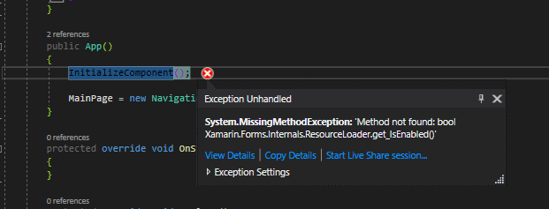

I have yet to find a solution to this problem, after googling and trying out the recommended methods. I even talked to the tutor about it but without any results as of yet.

**29-1-2020 (In Class)**

After trying *again* the recommended solutions and still not receiving any results I am trying to move my code into a new repo.

Final after moving all my code into a new app and copy pasting all my code it is working properly again! I am so relieved.

I’ve continued with adding the database to my app. And I intend on having 4 user slots to save your or family/friends progress assuming you share your device. I want to add 4 default users with default names; but only when there are no users in the database. I’ve been going through online resources and reading through Carel’s code from our team hangman project but I’m struggling with this new logic.

I think I have finally worked it out, but I get this message:

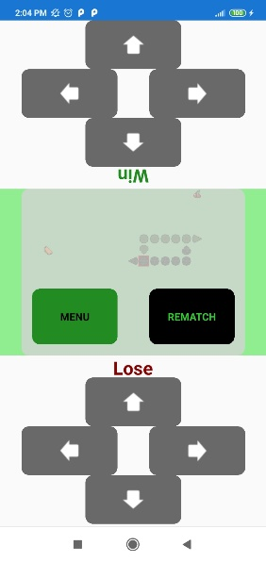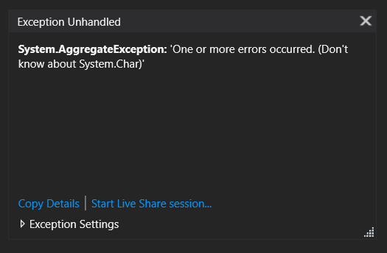

After commenting out parts of code the app functioned normally. Therefore, I realized that my database end is not working properly.

So for a change in pace I worked on creating an official end to the game that would allow the user to ether return to menu or play again with the current game settings. This is how it currently looks:

I’ve been working on getting both the buttons working yet remaining out of the way during the game so the user can’t press them. Both functions are working as intended and I’m working on displaying the following single player information:

* Final Score
* Snake’s length
* Fruits Eaten
* Chilies Eaten

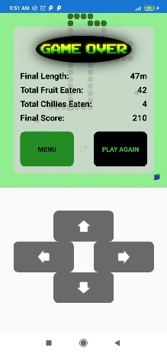

**4-2-2021 (In Class)**

I have successfully finished the single player game result it looks like this:

Now I am back to trying to get the database up and running.

I managed to find what was causing my errors and enabled the app to crash. Apparently bools and chars are not suitable data types for the models and by changing this the error was resolved.

Unfortunately due to the fact that the most of the day was spent learning what makes a good CV and Cover Letter I did not get as much done as I would have liked.

**5-2-2021 (In Class)**

After trial and error I have allowed the User to update the active user’s name. Also now you can view your current User’s stats except for your best score as I have not got it working yet. Also now when playing single player the fruit and chilies eaten numbers are added to the database.

While trying to get the high score going I ran into an error on this line:

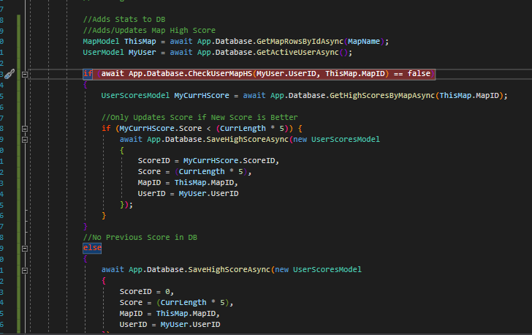

I

I

I don’t know what about that line causes the app to crash. I’m clueless. After uninstalling my app from my phone and debugging again to hopefully remove the error. I got an error saying that Map Models doesn’t exist. Except… It clearly is in my Models Folder. This may mean I would have to remove and recreate the app all over again. But first I’m going to remove the pages with it on and see if it improves the situation.

Clearly it didn’t work:

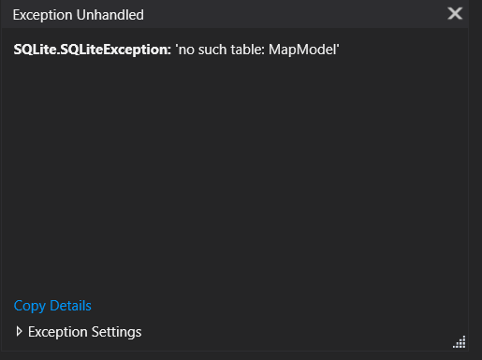

I can’t find a solution I may have to move all my code to a new app again.

After looking again carefully at my code I came to the realization that earlier when I renamed the MapModels as it was earlier confused by MapRowModels I forgot to rename it in the DB here:

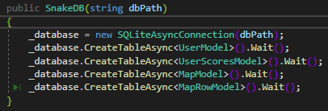

Instead it was MapRowModels twice here so I never got an error message by fixing this the error was thankfully resolved. Although when my snake dies in single player I still get this error message when trying to check the high scores for the current map:

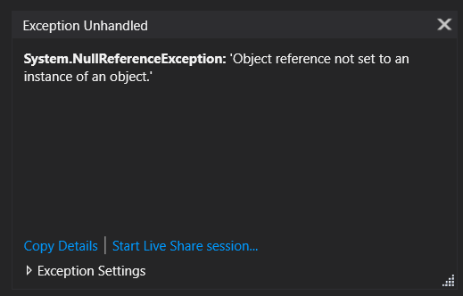

I will try and resolve this next time.

**11-2-2021**

Still trying to resolve the issue from last week. I’m pretty sure that this error is caused by something in the UserScoreModel.

Part of this issue was cause by once again the UserScoreModel had a foreign key that links to the MapRowModel instead of the MapModel. After fixing this it allowed the logic to run further through the code although, from further investigation I learned that while trying to create a new high score there was no MapID pulled through giving an error. I need to work out what is going on in this area.

The problem was that unfortunately I forgot to get the Map name from the game select button and had instead provided a temporary string to allow no errors, while I had no need for the name. This was regrettable. After ensuring it will work properly for the two maps it is now storing the user’s high score for each map properly.

**12-2-2021**

To complete this assessment I still need to do the following:

1. Allow user to select any of the four saves
2. Display high scores in high score page (DESC)
3. Get the map working to display properly
4. Allow user to select snake skin color

I have started working on allowing the user to change save/active user but currently I can only display the other user’s name. Perhaps I should also prevent multiple of the same user name…

I have started trying to run a function when an item from the picker is selected, but I haven’t figured out how to get the app to detect this and run the function further work is required.

**16-2-2021**

Trying to finish the assessment off completely. With more research I was able to find and implement into my code a way to run the selected item from the picker. It is now working and you are able to change users now. To which I am thankful.

Next I am working on displaying the high scores for the users to see and compare.

After struggling to figure out how to alter my code to allow using an inner join in the database page to allow the user ID to find the Username. However I found that sqlite with linq does not support the use of joins. To work around this I have changed the Scores Model to store Username. This may not be the most efficient way but I know this will work.

It works… But should a user change their username the High Score still stores the old name until the user beats the score in that map. This will be acceptable for now.

I’m trying to use a picker to allow the user to filter through the maps and only show the High Scores for the specified map though it is currently crashing at the moment.

**17-2-2021**

I’m confused with what is causing the crash when filtering the map. I have used the same code to store the high score and it works fine. I’m not sure what’s causing it but I need to work it out.

The page where it works the string is:

No Walls

The page where it is not working the string is:

No Walls

I have checked there is no difference in spacing or anything the only difference is the one page(Logic) allows the function to run; while the other(HS page) throws this exception consistently:

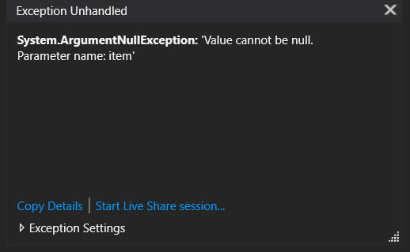

I don’t have a clue in the slightest at why it allows the function to run appropriate on the different pages. I am at a total loss.

I have tried to get the map to generate based on the DB. But am receiving the following error:

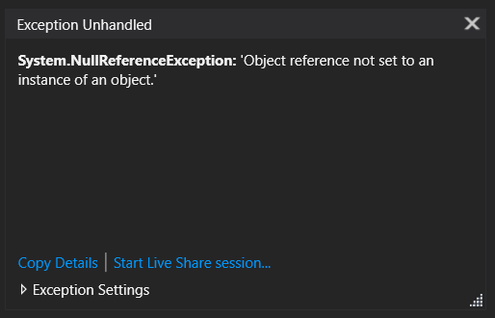

Even after creating a function that takes the Map Name and returns the ID I found that the when the function was called in the logic page it worked fine. But even when it sends the **exact** same string to the function the function only worked when saving the single player high score or getting the Map Id to build the grid. Why it doesn’t work on the high score page has me dumbfounded.

**18-2-2021**

I finally managed to solve the high score problem by moving the get Map ID function to the moment you select a Map Name from left to right:

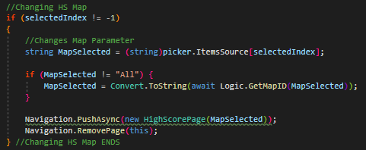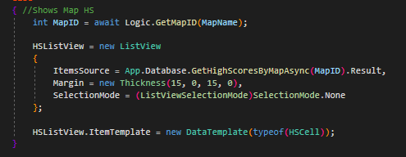

It now works properly. Why it doesn’t work on the left though I have no clue.

After what worked for the high score page I thought I would try and remove the code below the grid placing it first. And interestingly enough it ran to the point where I could visually see a grid. Although the grid does take a long while to load. If I leave out the fruit and snake movement function it works perfectly. I realized that as the rows of the gird loaded it took longer and longer. I hypothesized that this was because I originally had a switch with the numbers 0-24; so after loading the first few rows it would take far longer to load the last through as it had to check the requirements of all the first few.

After adding the data to an array and then looping through the array I found it loaded notably faster. But it was still a bit slow. No matter what I tried it was consistently too slow, I was pleased that I knew how to gain the information and display it and for me that was sufficient for my knowledge. I decided to make it a lot simpler and just have two different functions for loading the map.

After removing all the data and code connected to the map row model and also adding code to generate the appropriate map. It now runs a **lot** faster.

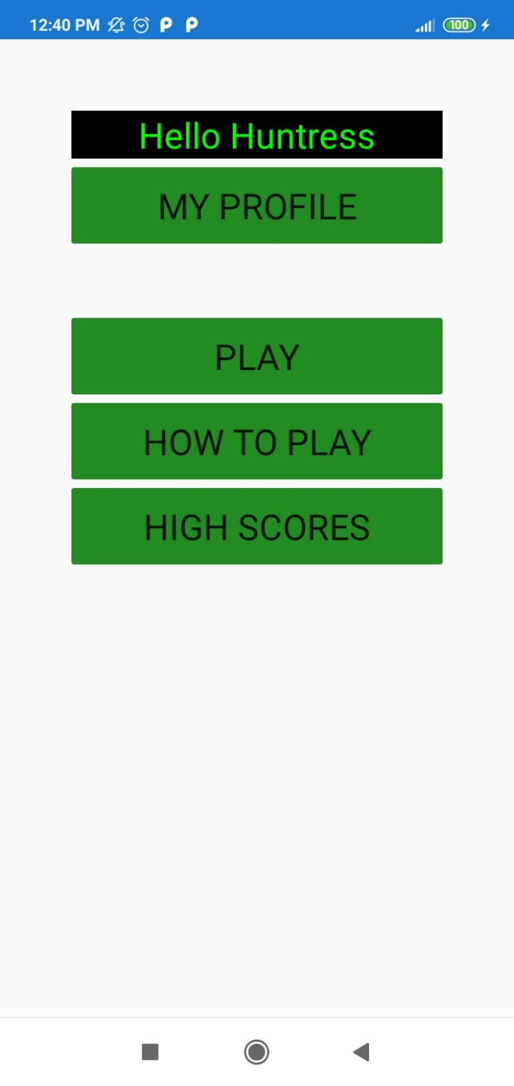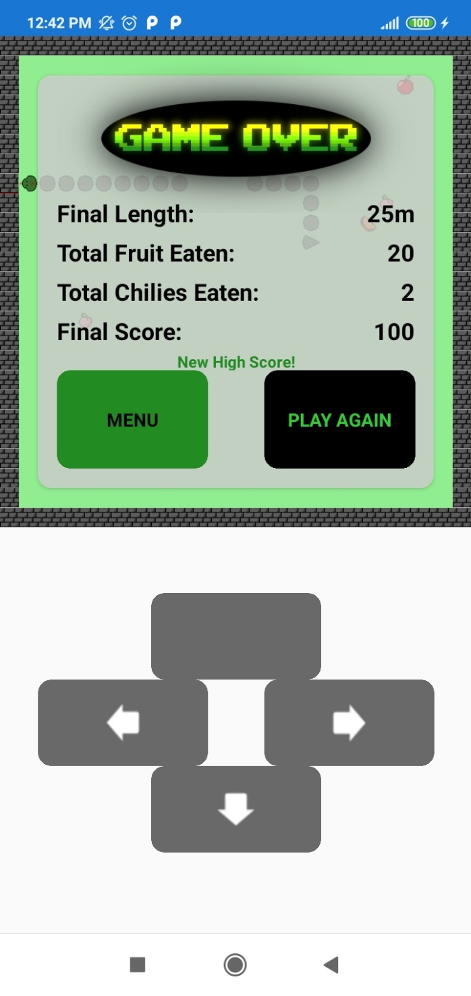After just a little bit of fixing minor mishaps in the code it is now running perfectly. This concludes my app.